Department of Computer Science and Engineering
2025-2026
Odd Semester


DATA STRUCTURES AND ALGORITHMS-3
(25CS2103E)

PatternX: Multi-Pattern Search Engine

DEVIKA 2520030329
TANMAYEE 2520030339

COURSE INSTRUCTOR

Dr. J Sirisha Devi
Professor
Department of Computer Science and Engineering
PatternX: Multi-Pattern Search Engine

1. Abstract
PatternX is a browser-based multi-pattern search application that finds several keywords or patterns in a single body of text. A conventional approach searches for each keyword separately, repeatedly traversing the same text. PatternX uses the Aho–Corasick string-matching algorithm to organize all requested patterns in a Trie and build failure links using breadth-first search (BFS). The text is then scanned in one pass, allowing the application to report the patterns found and their occurrence positions efficiently.
The website is designed as an interactive dashboard. Users can enter multiple patterns, paste text, or upload supported text-based files such as TXT, LOG and CSV. Text-based PDF files can also be processed when their text is extractable. The dashboard presents match counts and positions, processing-time measurements, and summary information such as the number of Trie nodes. Additional interface features can include result filtering, severity labels based on editable keyword rules, scan history for the current session, and CSV/JSON report export. The project demonstrates how a classical data-structures algorithm can be incorporated into a practical web application.
2. Problem Statement
Searching a document for many different terms is a common task in text analysis. A simple solution loops through every pattern and searches the complete document independently. If there are many patterns or the input text is large, this repeats work and can increase processing time. It can also be difficult for a user to compare the results when matches are displayed separately or without their positions.
The problem addressed by PatternX is to provide a single, clear interface that accepts multiple patterns and scans a text input efficiently, returning every detected occurrence and its location. The application should be understandable to students, responsive in a browser, and useful for inspecting logs, documents, sample messages, or other text. It should also explain the algorithmic process and provide measurable output for testing.
3. Objectives
Implement the Aho–Corasick algorithm using a Trie and failure links.
Search multiple patterns during one traversal of the input text.
Display each pattern’s occurrence count and zero-based match positions.
Support direct text input and supported text-based file uploads.
Show useful metrics such as Trie-node count and build/search time.
Provide a simple dashboard for filtering, reviewing, and exporting results.
Evaluate correctness with test cases including matches, missing patterns, repeated matches, and overlapping patterns.
4. Brief Description of the Case Study
4.1 Background and motivation
Consider a student reviewing a large server log for several terms such as ERROR, WARNING, TIMEOUT and LOGIN. Searching each term individually requires multiple passes over the same text. The same issue appears in document analysis, keyword extraction, basic content moderation, log inspection, and educational demonstrations of string matching. PatternX brings the pattern list, input text, and output into one interface so that the results can be checked together.
4.2 Proposed system
The user enters a set of patterns and provides text by pasting it or uploading a supported file. The application validates the inputs, builds a Trie from the patterns, computes failure links, and scans the text. Whenever the automaton reaches a state associated with one or more patterns, the engine records a match. The dashboard groups matches by pattern and displays counts and positions. If severity rules are enabled, a matching keyword can be assigned a user-configured label; this label is a rule-based aid, not a machine-learning or security guarantee.
4.3 Main modules
Input module: accepts a pattern list, pasted text, or a supported file. Empty patterns are ignored or rejected to prevent invalid matches.
Trie construction module: inserts each pattern character by character and marks the terminal node with the completed pattern.
Failure-link module: uses BFS to connect a state to the longest suffix that is also a Trie prefix.
Search module: processes the text once and follows failure links when the next character has no matching edge.
Results module: collects pattern names, occurrence counts, and start offsets; overlapping occurrences are retained.
Dashboard and export module: presents results, allows filtering, and prepares CSV or JSON output.
4.4 Example use case
Suppose the patterns are “he”, “she”, “his” and “hers”, and the text is “ushers”. PatternX scans the text once. It detects “she” beginning at index 1, “he” beginning at index 2, and “hers” beginning at index 2. The results overlap because one occurrence can contain another. A correct multi-pattern matcher must report all of them rather than stopping after the first match.
4.5 Scope and assumptions
The core matcher operates on text characters and is case-sensitive unless the input is normalized before searching. Positions are zero-based JavaScript string offsets; these are not the same as one-based human character numbers and may differ from byte offsets for non-ASCII text. PDF support depends on extracting selectable text; scanned images require OCR, which is outside the core algorithm. Uploaded files are processed in the browser, and any live file monitoring depends on browser permissions and API support.
ALGORITHM / PSEUDO CODE

5. Algorithm Design
5.1 Aho–Corasick overview
Aho–Corasick is a multi-pattern string-search algorithm. It combines a Trie, which shares common prefixes among patterns, with failure links that tell the search where to continue after a mismatch. The automaton is built before scanning the text. After preprocessing, the text is traversed from left to right, and each character is processed through transitions and failure links.
5.2 Data structures
Trie node: stores character transitions, a failure link, and the patterns ending at that node.
Children map: maps a character to the next Trie node.
Failure link: points to the longest proper suffix of the current node’s string that is also a prefix represented in the Trie.
Output list: stores patterns that end at the current node, including patterns inherited from its failure state.
Queue: supports breadth-first traversal while failure links are constructed.
Match collection: maps each pattern to all start offsets where it occurs.
5.3 Step-by-step algorithm
Read the input patterns and remove empty entries. Preserve the original pattern string for display.
Create a root Trie node. For every pattern, start at the root and follow or create one child edge for each character.
At the final node of each pattern, store that pattern in the node’s output list.
Set the root failure link to the root. Add each root child to a BFS queue and set its failure link to the root.
While the queue is not empty, remove a node. For each outgoing character edge to a child, follow the parent’s failure link until a state with that character transition is found or the root is reached.
Set the child’s failure link to the matching transition if it exists; otherwise set it to the root. Append the failure state’s output patterns to the child’s output list.
Initialize the current search state to the root. Traverse the text character by character.
For each character, follow failure links while the current state has no matching transition and is not the root.
If a transition for the character exists, follow it. Otherwise remain at the root.
For each pattern in the current state’s output list, calculate start = currentIndex − patternLength + 1 and record that occurrence.
After the text has been scanned, calculate counts from the recorded positions and display the grouped results and timing metrics.
5.4 Pseudocode
BUILD-AUTOMATON(patterns):
root = new TrieNode()
for pattern in patterns:
node = root
for character in pattern:
if character not in node.children:
node.children[character] = new TrieNode()
node = node.children[character]
node.outputs.add(pattern)

root.failure = root
queue = all children of root
for child in queue:
child.failure = root

while queue is not empty:
current = queue.removeFront()
for each (character, child) in current.children:
fallback = current.failure
while fallback != root AND character not in fallback.children:
fallback = fallback.failure
if character in fallback.children:
child.failure = fallback.children[character]
else:
child.failure = root
child.outputs.addAll(child.failure.outputs)
queue.addBack(child)
return root

SEARCH(root, text):
state = root
matches = empty map
for i from 0 to length(text) - 1:
character = text[i]
while state != root AND character not in state.children:
state = state.failure
if character in state.children:
state = state.children[character]
else:
state = root
for pattern in state.outputs:
start = i - length(pattern) + 1
matches[pattern].append(start)
return matches
5.5 Complexity analysis
Let M be the total number of characters across all patterns, N be the text length, and Z be the total number of reported matches. Trie insertion takes O(M) time. Failure-link construction is linear in the automaton size under the standard Aho–Corasick analysis. Searching takes O(N + Z), because each text character is processed and every reported occurrence must be emitted. Overall, the expected time bound is O(M + N + Z), with memory proportional to the Trie/automaton plus stored output and match data. If all match positions are retained, the result storage can grow with Z.
5.6 Correctness rationale
The Trie represents every inserted pattern. During BFS, a child’s failure link is assigned to the longest suffix state that can be reached by following the already-computed failure links and the child character. Inherited outputs ensure that a pattern ending at a suffix state is also reported at the current state. During scanning, the current state represents the longest suffix of the processed text that is a Trie prefix. Therefore, whenever a pattern ends at the current position, its terminal output is available and its start index is calculated as currentIndex − patternLength + 1. This allows all matching patterns, including suffix-related and overlapping matches, to be reported.

CODE
The following is the core JavaScript search engine used to demonstrate the Aho–Corasick logic. It can be placed in a module such as src/ahoCorasick.js and called from the React interface. The UI is responsible for collecting patterns and text, displaying the returned match map, and measuring execution time.
export function searchMultiplePatterns(patterns, text) {
class Node {
constructor() {
this.next = new Map();
this.fail = null;
this.output = [];
}
}

const root = new Node();
root.fail = root;
const cleanPatterns = [...new Set(patterns)]
.map(p => String(p))
.filter(p => p.length > 0);

// 1. Build the Trie.
for (const pattern of cleanPatterns) {
let node = root;
for (const ch of pattern) {
if (!node.next.has(ch)) node.next.set(ch, new Node());
node = node.next.get(ch);
}
node.output.push(pattern);
}

// 2. Build failure links with breadth-first search.
const queue = [];
for (const child of root.next.values()) {
child.fail = root;
queue.push(child);
}

let head = 0;
while (head < queue.length) {
const current = queue[head++];
for (const [ch, child] of current.next.entries()) {
let fallback = current.fail;
while (fallback !== root && !fallback.next.has(ch)) {
fallback = fallback.fail;
}
if (fallback.next.has(ch)) {
child.fail = fallback.next.get(ch);
} else {
child.fail = root;
}
child.output.push(...child.fail.output);
queue.push(child);
}
}

// 3. Scan the text once and record every occurrence.
const matches = Object.fromEntries(cleanPatterns.map(p => [p, []]));
let state = root;
const input = String(text);

for (let i = 0; i < input.length; i++) {
const ch = input[i];
while (state !== root && !state.next.has(ch)) {
state = state.fail;
}
state = state.next.has(ch) ? state.next.get(ch) : root;

for (const pattern of state.output) {
matches[pattern].push(i - pattern.length + 1);
}
}

// 4. Return counts, positions, and a simple structural metric.
let trieNodes = 1;
const nodeQueue = [root];
for (let i = 0; i < nodeQueue.length; i++) {
for (const child of nodeQueue[i].next.values()) {
trieNodes++;
nodeQueue.push(child);
}
}

const results = cleanPatterns.map(pattern => ({
pattern,
count: matches[pattern].length,
positions: matches[pattern]
}));

return { results, trieNodes };
}

// Example:
// const result = searchMultiplePatterns(
// ["he", "she", "his", "hers"], "ushers"
// );
// Expected positions: she -> [1], he -> [2], hers -> [2].
Implementation notes:
The code uses Map for transitions and a queue represented by an array plus a head index.
Duplicate patterns are removed so that a repeated entry does not duplicate reported output.
Positions are zero-based JavaScript string offsets.
The example is a core engine module, not a replacement for the complete React dashboard and its file-reading components.
RESULTS

6. Test Cases and Results
The test cases below describe expected behavior of the Aho–Corasick core engine. Before submission, run the same cases in the final website and replace the illustrative output with screenshots captured from the actual running application.
Test | Patterns / Input | Expected result | Purpose
TC-01 | ["he","she","his","hers"] / "ushers" | she: [1]; he: [2]; hers: [2] | Suffix and overlapping matches
TC-02 | ["cat","dog"] / "catdogcat" | cat: [0,6]; dog: [3] | Multiple and repeated matches
TC-03 | ["error","warn"] / "INFO ready" | Both counts are 0 | No-match case
TC-04 | ["aa"] / "aaaa" | aa: [0,1,2] | Overlapping occurrences
TC-05 | ["login","timeout"] / "login timeout login" | login: [0,13]; timeout: [6] | Repeated keywords
6.1 Example result
Input patterns: he, she, his, hers
Input text: ushers
Pattern | Occurrence count | Start positions (zero-based)
he | 1 | [2]
she | 1 | [1]
his | 0 | []
hers | 1 | [2]

6.2 Screenshot evidence

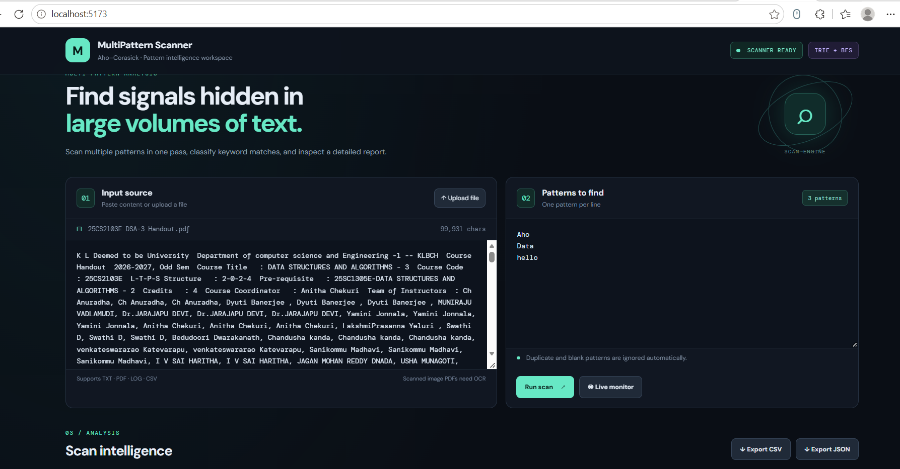
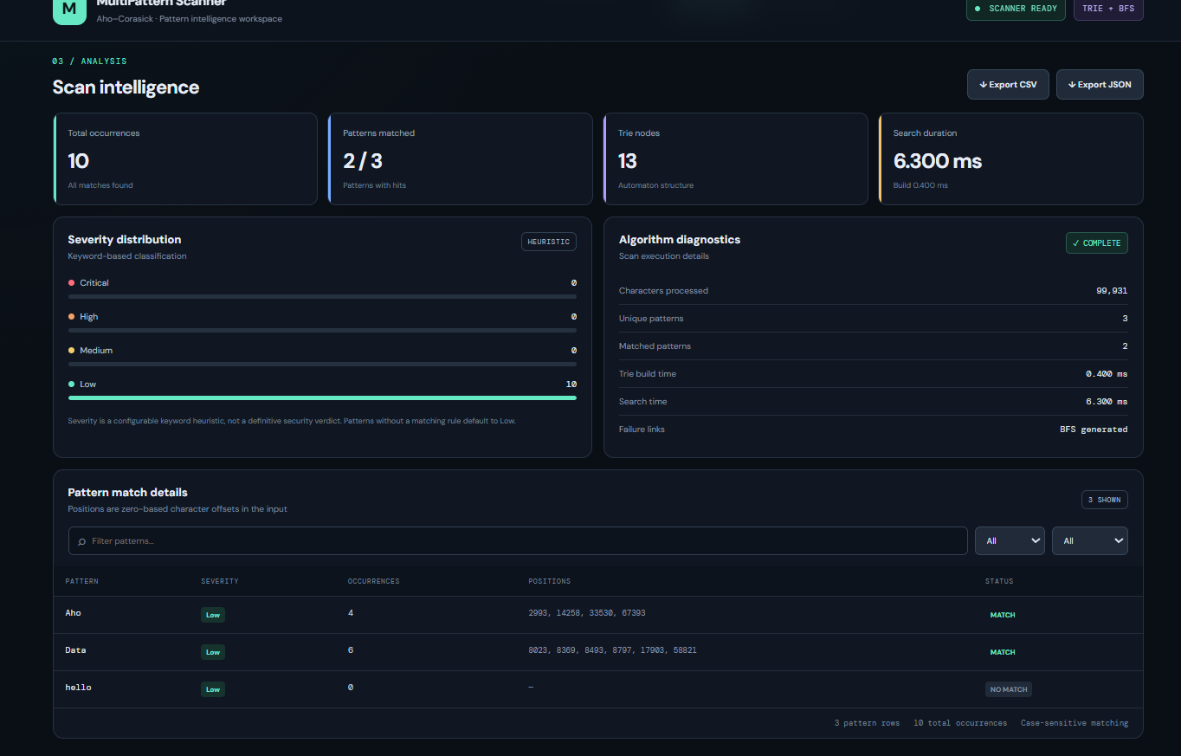

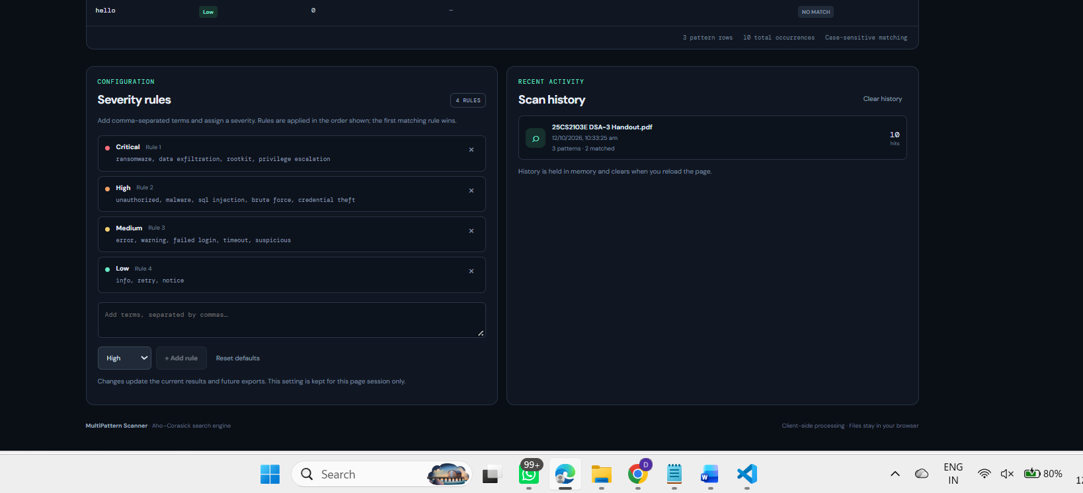

7. Limitations
Matching is case-sensitive unless normalization is applied consistently to patterns and text.
Scanned PDFs contain images rather than selectable text and need OCR before searching.
Severity labels, when used, are based on configured keyword rules and should not be treated as authoritative threat detection.
Large documents with very many matches can produce large result lists because every occurrence is recorded.
Timing values vary by browser, device, input size, and background activity; performance claims should be based on repeated tests.
8. Future Enhancements
Add case-insensitive search and optional whole-word matching.
Add OCR support for scanned PDF documents.
Support configurable Unicode normalization and clearer character-position reporting.
Allow users to save and reload pattern sets and export a complete scan report.
Add automated unit tests and performance benchmarks for different pattern and text sizes.
Improve accessibility, keyboard navigation, and large-result pagination.
9. Conclusion
PatternX demonstrates the use of the Aho–Corasick algorithm for efficient multi-pattern searching in a practical browser interface. A Trie shares pattern prefixes, BFS constructs failure links, and a single scan of the input text reports all detected occurrences, including overlapping matches. The dashboard makes the output easier to inspect through grouped counts, positions, and processing metrics. The project connects core DSA concepts with frontend engineering and can be extended with stronger testing, additional file-processing capabilities, and more flexible search options.
10. References
Aho, A. V. and Corasick, M. J. (1975). Efficient string matching: An aid to bibliographic search. Communications of the ACM, 18(6), 333–340.
MDN Web Docs. JavaScript Map object and File API documentation. https://developer.mozilla.org/
React documentation. https://react.dev/
PDF.js documentation, for extracting text from supported PDF documents. https://mozilla.github.io/pdf.js/

